# **The Newcastle Common Rooms**

**Introduction:** **1**

**Scope:** **1**

**User Profile:** **2**

**User Requirements:** **2**

**Client Requirements:** **3**

**Wireframe:** **3**

**Test Plan:** **5**

**Screenshots:** **6**

# 

# Introduction:

This document is about a multiple page website for the Newcastle Common Rooms where people can book places to use for different occasions.

# Scope:

I’m aiming to create a website from scratch. I’m not using any Content Management Systems or platforms because I want to use Cascading Style Sheets and gain control over the whole website. There will be seven pages which are linked together for navigating purposes.

Subjects I considered are:

* Layout of pages. (So the pages will load on all kinds of screens, big or small)
* Site structure. (Playing by the rules makes everything in the website run smoothly)
* Navigation. (Nobody wants to get lost on a website which is a huge disappointment)
* Meta Tagging (For Search Engine Optimisation purposes and all devices accessibility)
* HTML 5
* Cascading Style Sheet (To gain a full control over everything on my end)
* W3C (Validating the code helps with the missing parts)
* Images (so the visitor will determine which page they are in)
* Interactive features (Useful buttons to help the visitors with their purposes)
* Format of Content ( A Sitemap is available to all the pages of the website)

# User Profiles:

| Weddings | People at a certain age like between 25 to 55. |
| --- | --- |
| Birthdays | People of all ages. |
| Graduations | University students |
| Funerals | Adults only |
| Business meetings | Companies |

# User Requirements:

| Functionality | This website should simply serve the purpose of visitors and load reasonably quickly so the users will not be frustrated. (3 to 5 seconds) |
| --- | --- |
| Accessibility | This website should be accessible by disabled people and also should be accessible on desktop computers, laptops, tablets and mobile phones |
| User-Friendly | The visitors of this website should be able to navigate through every page of the website easily. |
| Security | This website should be a safe and secure place so the visitors can rely on the information they share. This will also help with users recommending the website to others to attract more visitors. |
| Maintenance | Like every product out there, the website should have a customer service system. |
| Regulations and Policies | Such as Data Protection and Privacy for the client |
| Reliability and availability | Every website needs updates at some point and it is very important to plan the construction and downtime. |
| Search Engine Optimisation | This has to be up to date so the users will find the website quickly. |
| Being a Dynamic Website | This website will be a dynamic website so the users can change some of their selections on the website. |

# 

# Client Requirements:

| Images & Icons | There will be Images and icons used on this website |
| --- | --- |
| History Of Region | There will be a description for the region on this website |

# Wireframe:

Homepage

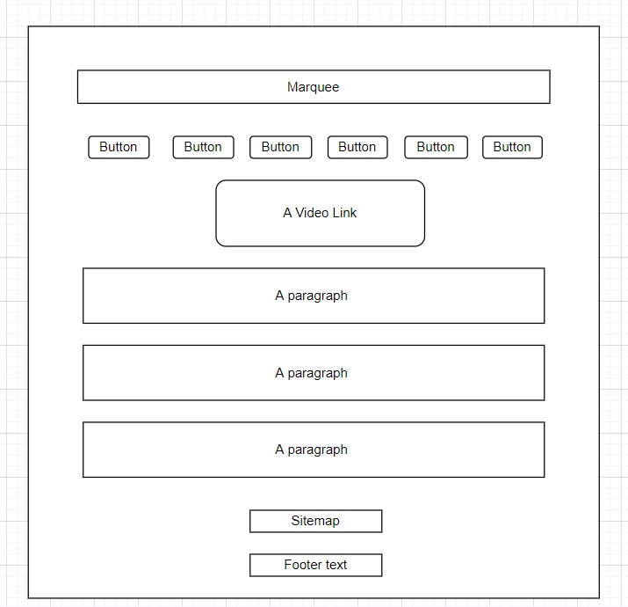

Page 2

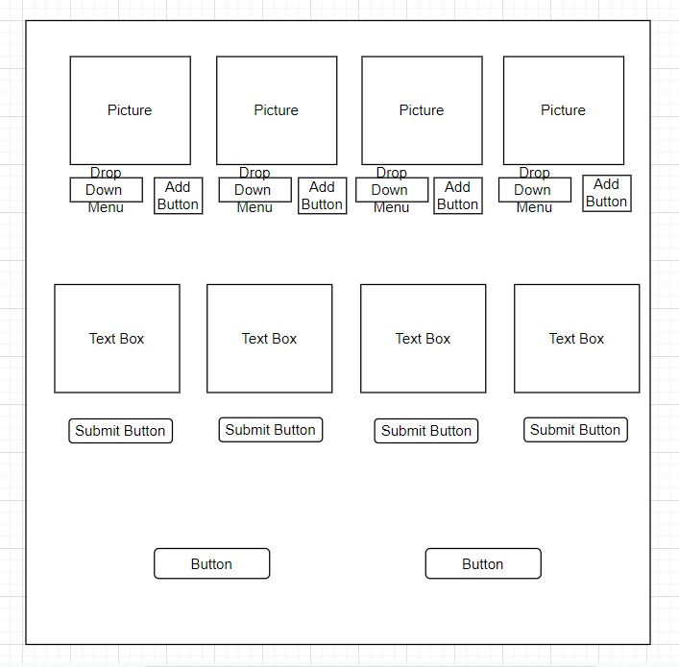

Page 3

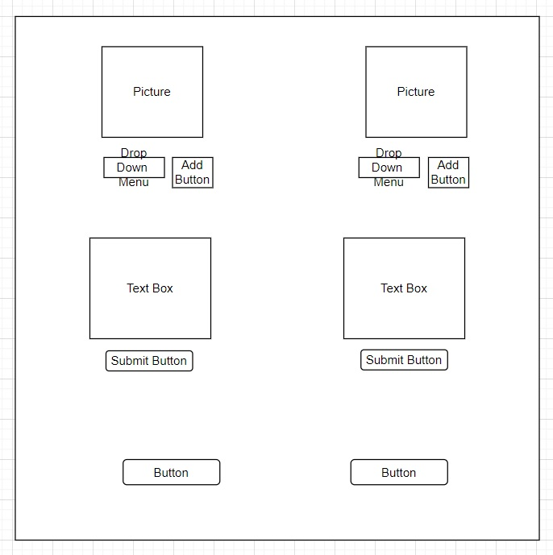

# Test Plan:

| **Test** | **Expected Result** | **Actual Results** | **Actions** | **Proof** |
| --- | --- | --- | --- | --- |
| Functionality | Loads fairly quickly?  ( 3 to 5 seconds ) | In about 3 seconds | None | Couldn’t upload on the internet |
| Serves the visitor’s purpose? | Yes | None | Screenshot of  Page 1 |
| Accessibility | Is the website accessible for disabled people | Yes | None |  |
| Is the website accessible on every device? | Yes | None | Screenshot of  Pages 2 & 3 |
| User-Friendly | Can the users navigate easily through the whole website? | Yes | None | All the links are working |
| Security | Does the website look genuine? | Yes | None | Screenshot of  All Pages |
| Search Engine Optimisation (Meta tags, SiteMap, Key words) | Does the website have enough requirements to be found easily on the internet? | Yes | None | Screenshot of  Page 5 & 6 |
| Reliability and availability | Is data protection considered inside the website? | Yes  ( The third paragraph of the homepage is about the Privacy Policy ) | None | Screenshot of  Page 7 |
| Images & Icons | Does the website come with images, icons and graphics? | Yes | None | Screenshot of  All Pages |
| History Of Region | Is there a description for the region on the website? | Yes | None | Screenshot of  Page 1 |
| Dynamic website | Is the website dynamically serving the visitors? | Yes | None | Screenshot of  Pages 2 & 3 |
| W3C Validator | Is the code validated | Yes | None | Screenshot of  Page 8 |

# 

# Screenshots:

Page 1

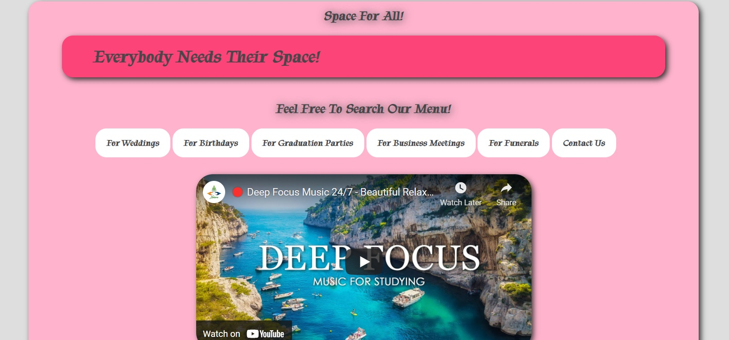

This is the homepage of the website with the navigation bar to search through other pages.

Page 2

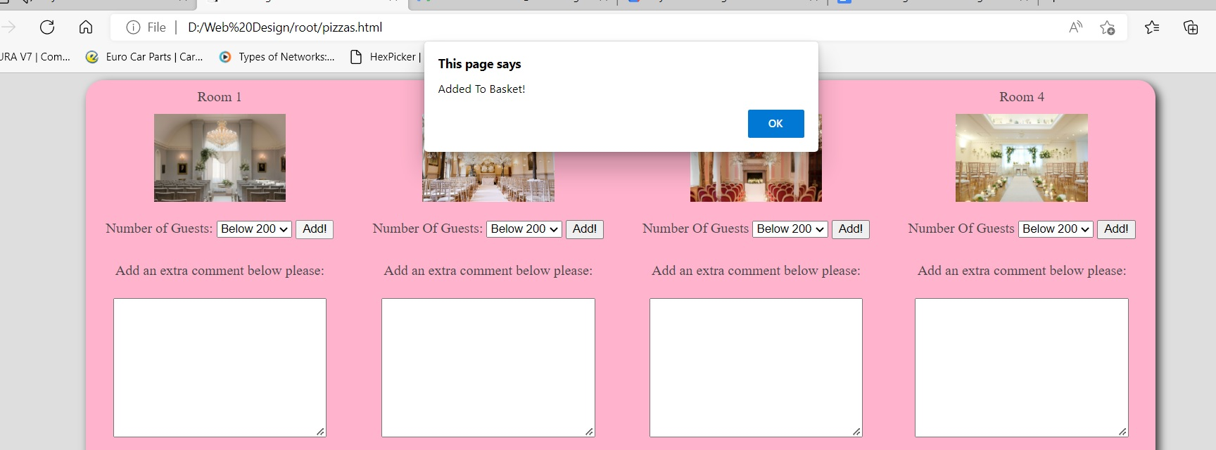

This page is “For Weddings” and the message appears after the user adds an item to the basket.

Page 3

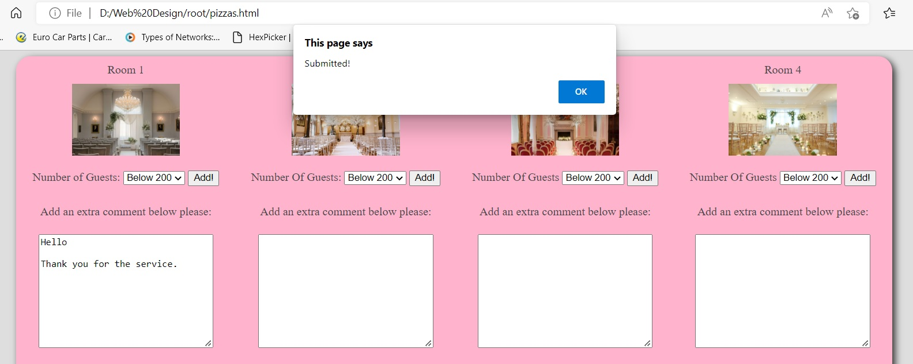

This is again “For Weddings” with a different message which appears when the user leaves a comment in the comment box.

Page 4

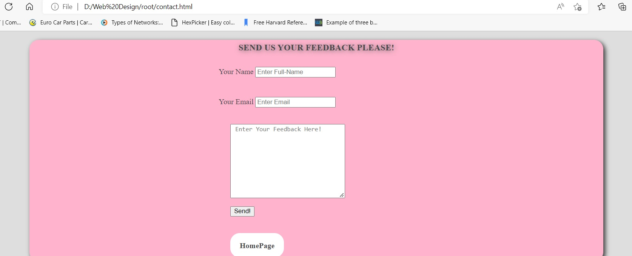

This is the “Contact us” page which is designed for users’ feedback and extra comments and request.

Page 5

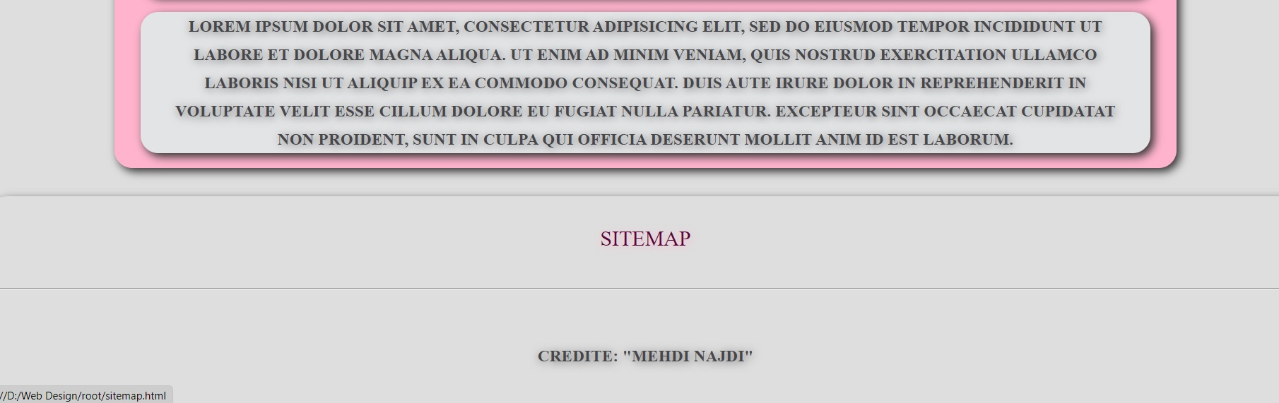

The sitemap button is available for Search Engine Optimisation purposes and people with certain disabilities.

Page6

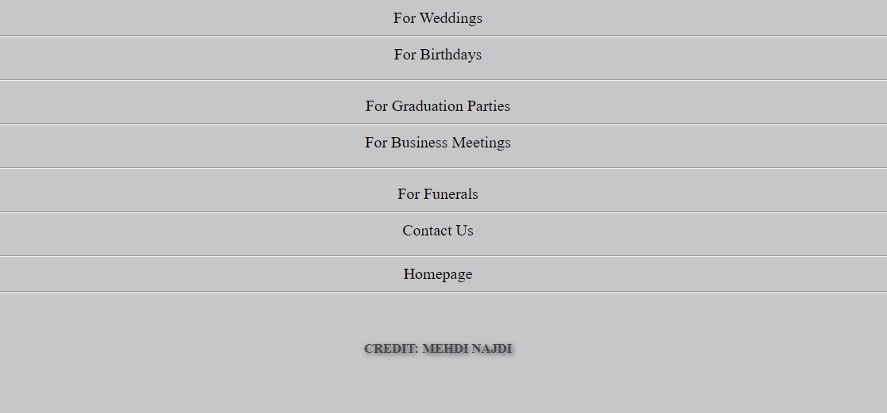

This is a screenshot of the sitemap page after the user clicks on the sitemap button.

Page7

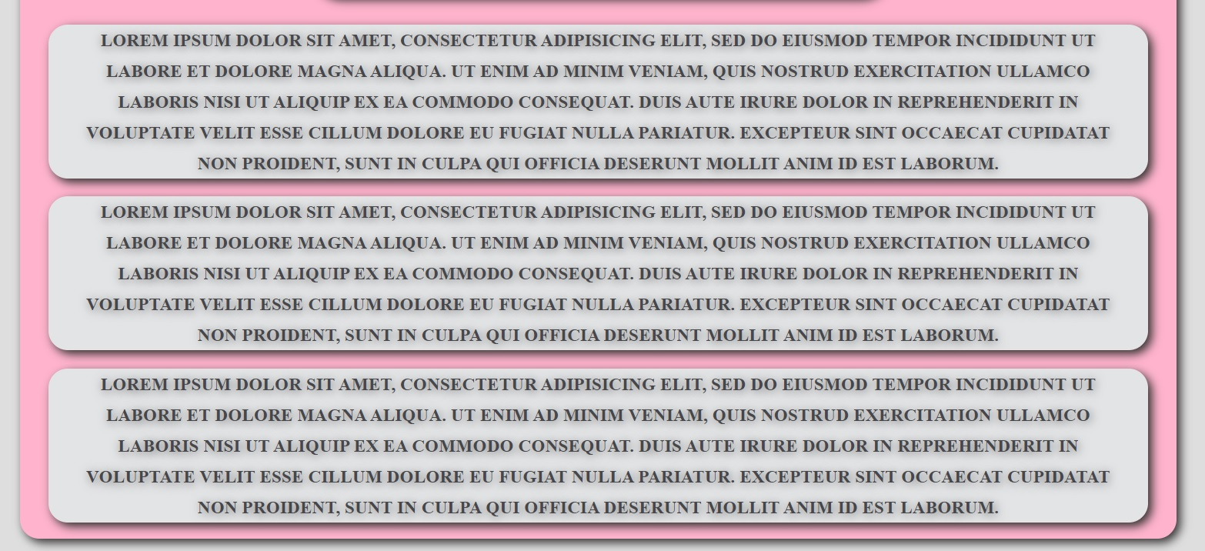

This is the front page of the website and the paragraphs are representing the history of region and the company.

Page 8

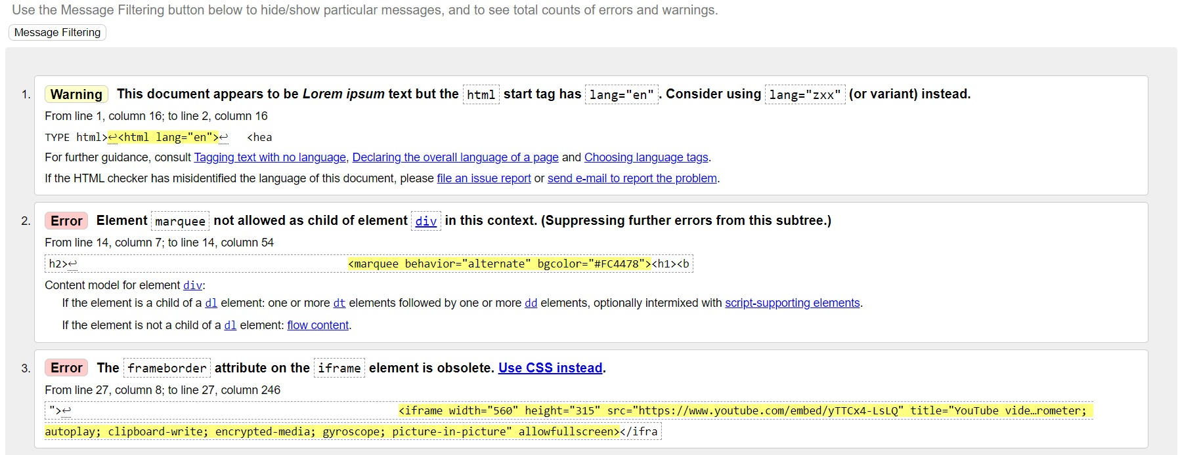

This screenshot shows the w3c testing tool that I used for the HTML code.

My code that was tested by w3c testing tool

